**PIZZA SALES SQL QUERIES**

1. **Total Revenue**

**SELECT SUM(total_price) AS TOTAL_REVENUE FROM pizza_sales;**

***Output:***

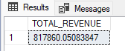

1. **Average Order Value**

**SELECT SUM(total_price) / COUNT(DISTINCT order_id) AS AVG_ORDER_VALUE FROM pizza_sales;**

***Output:***

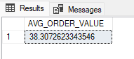

1. **Total Pizza Sold**

**SELECT SUM(quantity) AS TOTAL_ORDERS_SOLD FROM pizza_sales;**

***Output:***

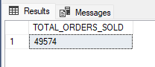

1. **Total Orders**

**SELECT COUNT(DISTINCT order_id) AS TOTAL_ORDERS FROM pizza_sales;**

***Output:***

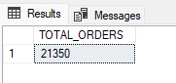

1. **Average Pizzas Per Order**

**SELECT CAST (CAST(SUM(quantity) AS DECIMAL (10,2)) /**

**CAST(COUNT(DISTINCT order_id) AS DECIMAL (10,2)) AS DECIMAL (10,2))**

**AS AVG_PIZZA_PER_ORDER**

**FROM pizza_sales;**

***Output:***

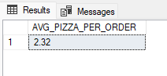

1. **Daily Trend For Total Orders:**

**SELECT DATENAME(DW, order_Date) AS ORDER_DAY,**

**COUNT(DISTINCT order_id) AS TOTAL_ORDERS**

**FROM pizza_sales**

**GROUP BY DATENAME(DW, order_date);**

***Output:***

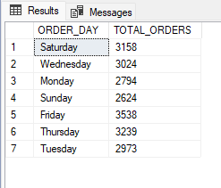

1. **Monthly Trend For Total Orders**

**SELECT DATENAME(MONTH, order_date) AS MONTH_NAME,**

**COUNT(DISTINCT order_id) AS TOTAL_ORDERS**

**FROM pizza_sales**

**GROUP BY DATENAME(MONTH, order_date)**

**ORDER BY TOTAL_ORDERS DESC;**

***Output:***

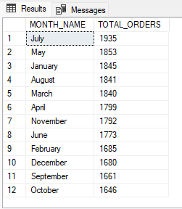

1. **Percentage of Sales By Pizza Category**

**SELECT pizza_category, SUM(total_price) * 100 / (SELECT SUM(total_price)**

**FROM pizza_sales) AS PERCENTAGE_OF_TOTAL_SALES**

**FROM pizza_sales**

**GROUP BY pizza_category;**

***Output:***

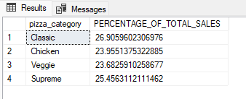

1. **Percentage of sales by pizza size**

**SELECT pizza_size, CAST (SUM(total_price) * 100 / (SELECT SUM(total_price)**

**FROM pizza_sales) AS DECIMAL (10,2)) AS PERCENTAGE_OF_TOTAL_SALES**

**FROM pizza_sales**

**GROUP BY pizza_size**

**ORDER BY PERCENTAGE_OF_TOTAL_SALES DESC;**

***Output:***

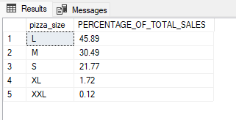

1. **Total pizzas sold by pizza category**

**SELECT pizza_category, SUM(quantity) AS TOTAL_PIZZAS_SOLD**

**FROM pizza_sales**

**GROUP BY pizza_category;**

***Output:***

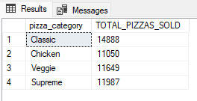

1. **Top 5 Pizzzas by revenue**

**SELECT TOP 5 pizza_name, SUM(total_price) AS TOTAL_REVENUE**

**FROM pizza_sales**

**GROUP BY pizza_name**

**ORDER BY TOTAL_REVENUE DESC;**

***Output:***

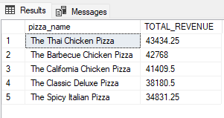

1. **Bottom 5 Pizzzas by revenue**

**SELECT TOP 5 pizza_name, CAST(SUM(total_price) AS DECIMAL (10,2)) AS TOTAL_REVENUE**

**FROM pizza_sales**

**GROUP BY pizza_name**

**ORDER BY TOTAL_REVENUE;**

***Output:***

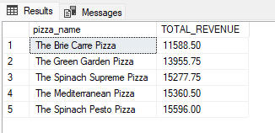

1. **Top 5 pizza by qty**

**SELECT TOP 5 pizza_name, SUM(quantity) AS TOTAL_QTY**

**FROM pizza_sales**

**GROUP BY pizza_name**

**ORDER BY TOTAL_QTY DESC;**

***Output:***

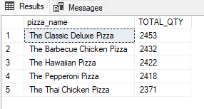

1. **Bottom 5 pizza by qty**

**SELECT TOP 5 pizza_name, SUM(quantity) AS TOTAL_QTY**

**FROM pizza_sales**

**GROUP BY pizza_name**

**ORDER BY TOTAL_QTY;**

***Output:***

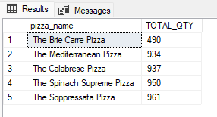

1. **Top 5 pizza wrt orders**

**SELECT TOP 5 pizza_name, COUNT(DISTINCT order_id) AS TOTAL_ORDERS**

**FROM pizza_sales**

**GROUP BY pizza_name**

**ORDER BY TOTAL_ORDERS DESC;**

***Output:***

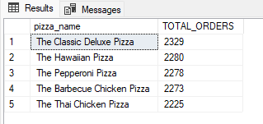

1. **Bottom 5 Pizzas wrt orders**

**SELECT TOP 5 pizza_name, COUNT(DISTINCT order_id) AS TOTAL_ORDERS**

**FROM pizza_sales**

**GROUP BY pizza_name**

**ORDER BY TOTAL_ORDERS;**

***Output:***

